**Movie Recommendation System**

From 15th February 2020 to 26th February 2020, I worked 30hrs/week. I built a Movie Recommendation system that predicts the movies to be recommended to the users.

I have used movie lens dataset to build a machine learning model working as recommendation system.

The complete explanation with the code is available at <https://github.com/mraunak/Research-Assistant-Work-/blob/main/Movie%20Recommendation%20System.ipynb>

The datasets used are rating.csv and movies.csv.

Below is the snippets of the datasets: ratings.csv

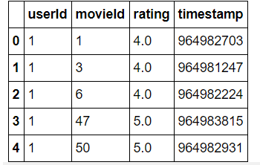

Below is the snipped of movies.csv

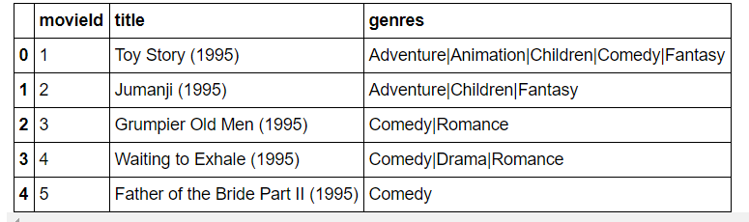

Method:

I have used Collaborative Filtering : The intuition behind collaborative filtering is that if a user A likes products Product1 and Product2, and if another user B likes Product1, there is a good chance that he will like the Product2 as well.

**Results**

The list of the movies that the user with UserID 1 will like

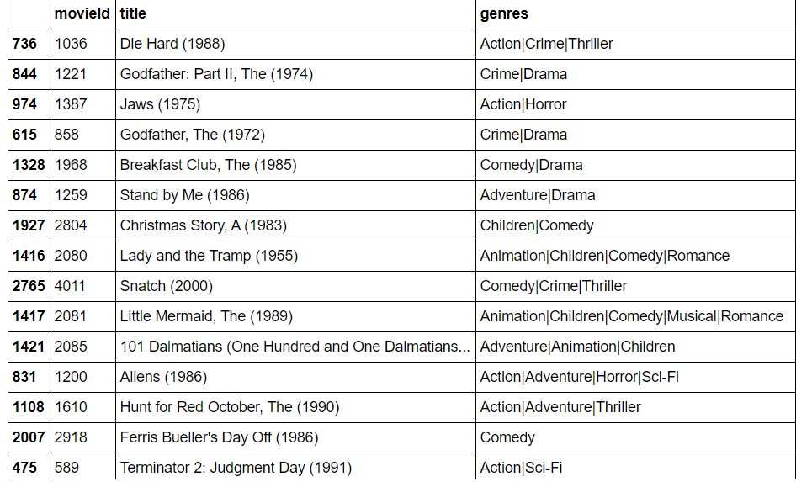

**Conclusion**

The recommendation engines have the potential to change the way websites communicate with users and to allow companies to maximize their ROI based on the information they can gather on each customer's preferences and purchases. In this Project, I designed a model-based Collaborative Filtering movie recommendation system based on latent features from a low rank matrix factorization method known as Singular Value Decomposition. Since, SVD captures the underlying features driving the raw data, it can scale significantly better to massive datasets as well as make better recommendations based on user's behavior. The above designed recommendation system can also be used in suggesting an item on the e-commerce website such as Amazon, eBay etc. It can also be used to suggest music, television programs, books, documents on google page, websites, conferences, tourism scenic spots and learning materials, and involve the areas of e-commerce, e-learning, e-library, e-government and e-business services.